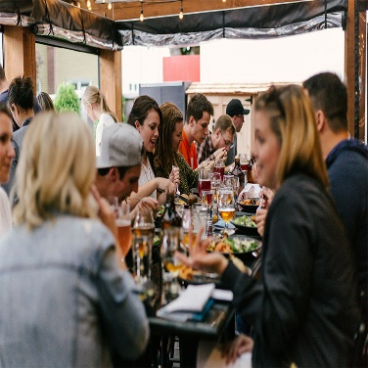 Celebrate good times, come on, you're invited and it's a sign!

Happy employees build great product and they take care customer

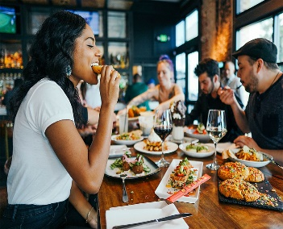 Join the crowd, let's get rowdy and loud, you're invited, it's a great gathering, don't be proud!